Memorandum University of Portland
Donald P. Shiley School of Engineering

Date: 10/9/11

To: Dr. Aziz Inan

From: xxx

Subject: Midterm Design Proposal Draft

Team: C7

The purpose of this memo is to introduce the attached report. This report is Team C7’s Design Proposal for this year’s Freshman Design Competition. Team C7 consists of xxx, xxx, xxx, and xxx.

The Design Competition this year consists of collect blocks off a tiered platform, transporting them across one of four obstacles of varying difficulty, and depositing them in a scoring zone. Teams will compete for three awards in order to move on to the second round. We have decided to pursue the Points per Time Award, sparing no expense. The estimated cost of our device (including the basic LEGO® MINDSTORMS® kit) is $600. This report will provide an overview of the competition, our design, our budget, and our schedule.

Midterm Design Proposal
EGR110C
University of Portland

Submitted to Dr. Aziz Inan

xxx
Team C7
Xxx, xxx, xxx, xxx
10/9/11

Table of Contents

- Introduction . . . . . . . . . . . . . . . . . . . . . . . . . . . . . . . . . . . 4
- Background . . . . . . . . . . . . . . . . . . . . . . . . . . . . . . . . . . . 4
  - Competition Overview . . . . . . . . . . . . . . . . . . . . . . . . . . . 4
  - Scoring and Awards . . . . . . . . . . . . . . . . . . . . . . . . . . . 4
  - Team Goal . . . . . . . . . . . . . . . . . . . . . . . . . . . . . . . 5
- Design Overview . . . . . . . . . . . . . . . . . . . . . . . . . . . . . . . . . . . 5
  - Design Process . . . . . . . . . . . . . . . . . . . . . . . . . . . . . . . 5
  - Design Alternatives . . . . . . . . . . . . . . . . . . . . . . . . . . . 5
  - Chosen Alternative . . . . . . . . . . . . . . . . . . . . . . . . . . . 6
- Testing Plan . . . . . . . . . . . . . . . . . . . . . . . . . . . . . . . . . . . 12
- Budget and Schedule . . . . . . . . . . . . . . . . . . . . . . . . . . . . . . . 12
  - Materials and Costs . . . . . . . . . . . . . . . . . . . . . . . . . . . 12
  - Schedule . . . . . . . . . . . . . . . . . . . . . . . . . . . . . . . . . . . 12
- Summary . . . . . . . . . . . . . . . . . . . . . . . . . . . . . . . . . . . . . . . 13
- References . . . . . . . . . . . . . . . . . . . . . . . . . . . . . . . . . . . . . . . 13

- Introduction
The “First Year Design Project” is a competition primarily intended to be a fun and engaging method for students in the EGR 110 (Introduction to Engineering) class to learn about different disciplines within the field of engineering. During this semester-long project, the members of Team C7 will use LEGO® MINDSTORMS® to learn how to design, create, and program a robot to pick up and carry blocks across an obstacle and deposit them in a scoring box. In addition, Team C7 will expand on useful skills such as teamwork, organization, and writing (specifically technical writing). The purpose of this report is to provide a summary of the design project and detail Team C7’s plans, goals, and progress throughout the project. The Background section gives an overview of the competition and awards while the Design Overview section details the design of the robot Team C7 plans to build. The testing plan can be found in the fourth section and budget and schedule in the fifth. The Summary section provides a concise summary of this report and the references used can be found in the References section. Much of the information in this report about the design project comes from the First Year Design Project handout [1]
- Background
The following section describes the 2011 competition and the awards that the teams will compete for. It also articulates Team C7’s goal for the competition.
2.1 Competition Overview
The ultimate objective of the 2011 competition is to deposit wooden blocks into a scoring zone. Each robot begins in the start area, opposite the scoring zone, and during the three-minute competition period the robots operate completely autonomously. The wooden blocks are placed on a tiered platform in front of the start area, towards the middle of the competition field, with 5 blocks on each of the three tiers. Between this platform and the scoring zone are four paths: the first is entirely without obstacles, the second features the “stairs” obstacle, the third features the “ravine” obstacle, and the fourth features the “windmill” obstacle. In the scoring zone is a “bonus box”, should teams desire to place the blocks there for extra points. A more thorough description of the competition as well as a diagram of the competition area can be found in the First Year Design Project handout [1].
2.2 Scoring and Awards
Teams earn points by depositing blocks into the scoring zone and/or the bonus box. The multiplier values associated with the obstacles are based on the difficulty of navigating each obstacle. Blocks’ point values are based on which tier they started on. The specific values and multipliers are described in Table 1, below.

Table 1 – Competition Scoring
  Tier | Block Value
  Bottom (floor) | 1
  Middle | 3
  Top | 5
  Obstacle | Multiplier Value
  Floor | 1
  Ravine | 2
  Stairs | 3
  Windmill | 4
  Scoring Zone | Multiplier Value
  Floor | 1
  Bonus Box | 3

Scores are calculated by multiplying each block’s value by the multiplier value of the path taken and the end-zone (scoring) area and then adding the resultant values of the blocks.
Teams will compete for three awards to advance to the second round: highest score per time, highest score per cost, and most creative design. A team may only win one award; should a team win more than one award, it will only be given the highest preference award it won and the other(s) will be given to the runners up. The three finalists from the first round will move on to compete in the second round. The overall winner of the competition is the team that wins the most points in this round.
2.3 Team Goal
The members of Team C7 have decided to attempt to win the “highest score per time” award, completely disregarding cost. In order to do this, Team C7’s robot will attempt to gather the blocks from the top and bottom tiers, go over the ravine, then deposit the top-tier blocks into the bonus box and the bottom-tier blocks onto the ground.
3.0 Design Overview
This section provides a summary of the design process. It discusses the design chosen by Team C7 as well as the alternative designs the team considered.
3.1 Design Process
In order to design the robot, Team C7 had to do some proof-of-concept and prototype testing for some type of bucket and gathering device. It was discovered through these preliminary tests that, with the right dimensions, the concept would work. Team C7 also did extensive programming tests, to discover what could and could not be done from a programming standpoint. With this information, Team C7 went on to consider different alternatives.
3.2 Design Alternatives
Team C7 considered many options, most of which centered on taking the stairs obstacle. The first alternative was to build the robot with a wide enough wheel base that the robot could drive over the stairs without climbing them. This idea was abandoned due to the decreased accuracy in steering that such a wheel base would cause. The next alternative considered was to build a ramp to drop over the near side of the stairs to make climbing them easier. The ramp would be attached to the robot with a one-time release mechanism made mainly out of rubber bands. This was the favorite alternative but a little too complicated and so was also abandoned. Team C7 ruled out the windmill obstacle near the beginning because it was all too likely that the robot would touch the blades and bring the multiplier value down to that of the ravine. The last alternative, the one that was ultimately chosen by Team C7, was to gear the robot up to full speed and jump the ravine after gathering the blocks. This seemed the least complicated method for completing the course.
Two constants in every design alternative considered were a bucket for blocks on the tiered platform and a bulldozer-like device for blocks on the ground.
3.3 Chosen Alternative
Team C7 chose to create a robot that could jump the ravine with as many blocks as possible. A bucket device, detailed in Figure 4, will be used to gather blocks from the top tier while a bulldozer device, detailed in Figure 5, will be used to gather the bottom-tier (ground-level) blocks. The robot will be programed to bulldoze the ground-level blocks from the front (using the tiers to push the blocks into the box) while simultaneously collecting the top-tier blocks with the bucket. The robot will then drive over the ravine at full speed before depositing the blocks from the bucket into the bonus box.
The bucket will be attached to the robot by two arms on the front and back of the robot, which are in turn attached to a motor to provide movement – driving the motor forward will cause the bucket to more down and driving it backwards will cause the bucket to move up. A carriage mount will be used between the bucket and arms so that no matter what position the arms are in, the bucket stays upright, similar to a Ferris wheel. There will also be a gathering device attached to the bucket that is free to swing. Two stops will be added to keep the gathering device from falling below 0° or above 90°. To gather blocks, the robot will behind the tiers and slowly lower the bucket in such a way and the gathering device falls over the blocks then catches on the edge of the tier, slowly rising while guiding the blocks into the bucket. To deposit the blocks, the bucket will be lowered until it catches the edge of the bonus box and tips, dumping the blocks into the bonus box.
The bulldozer device will be attached to the front of the robot and shaped like a shoe box. It will have a flap on the inside that swings freely. The front frame of the device will be wide enough (¼ inch) to stop this flap from rotating forward. When the robot drives up to a block, the block will push the flap into the box, allowing the block into the box. However, if the block pushes the flap from the inside, the flap will be unable to rotate and the block will stay in the box. The box has a bottom to it to prevent the blocks from falling out when the robot jumps the ravine. The blocks gathered in this box will score just by being within the scoring zone at the end of the round and so will only receive the multiplier of one.
The robot itself will have just three wheels (for ease and precision in turning). To counteract the weight of the bucket device, the NXT brick and all motors will be put towards the bottom of the robot. An overall design for the robot can be seen in Figures 1, 2, and 3.
The advantages in this design over the others that were considered lie in its simplicity: in using gravity to power the gathering device and the flap, only three motors need to be used and by collecting multiple levels of blocks simultaneously, time is saved. Disadvantages of this design include its inability to gather the middle tier blocks and its inability to deposit all blocks in the bonus box. One potential problem with this design is that it is possible that when loaded down, the robot will not be able to make the jump over the ravine. Should this prove true in testing, another alternative will have to be considered.

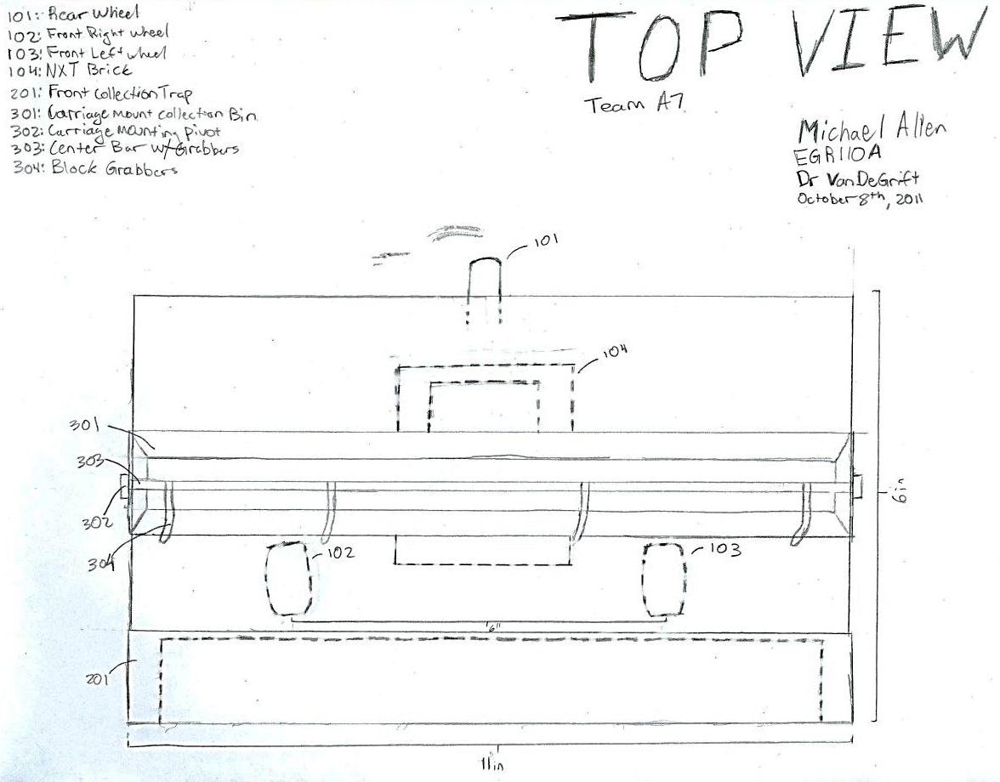
Figure 1 – Top View of Robot
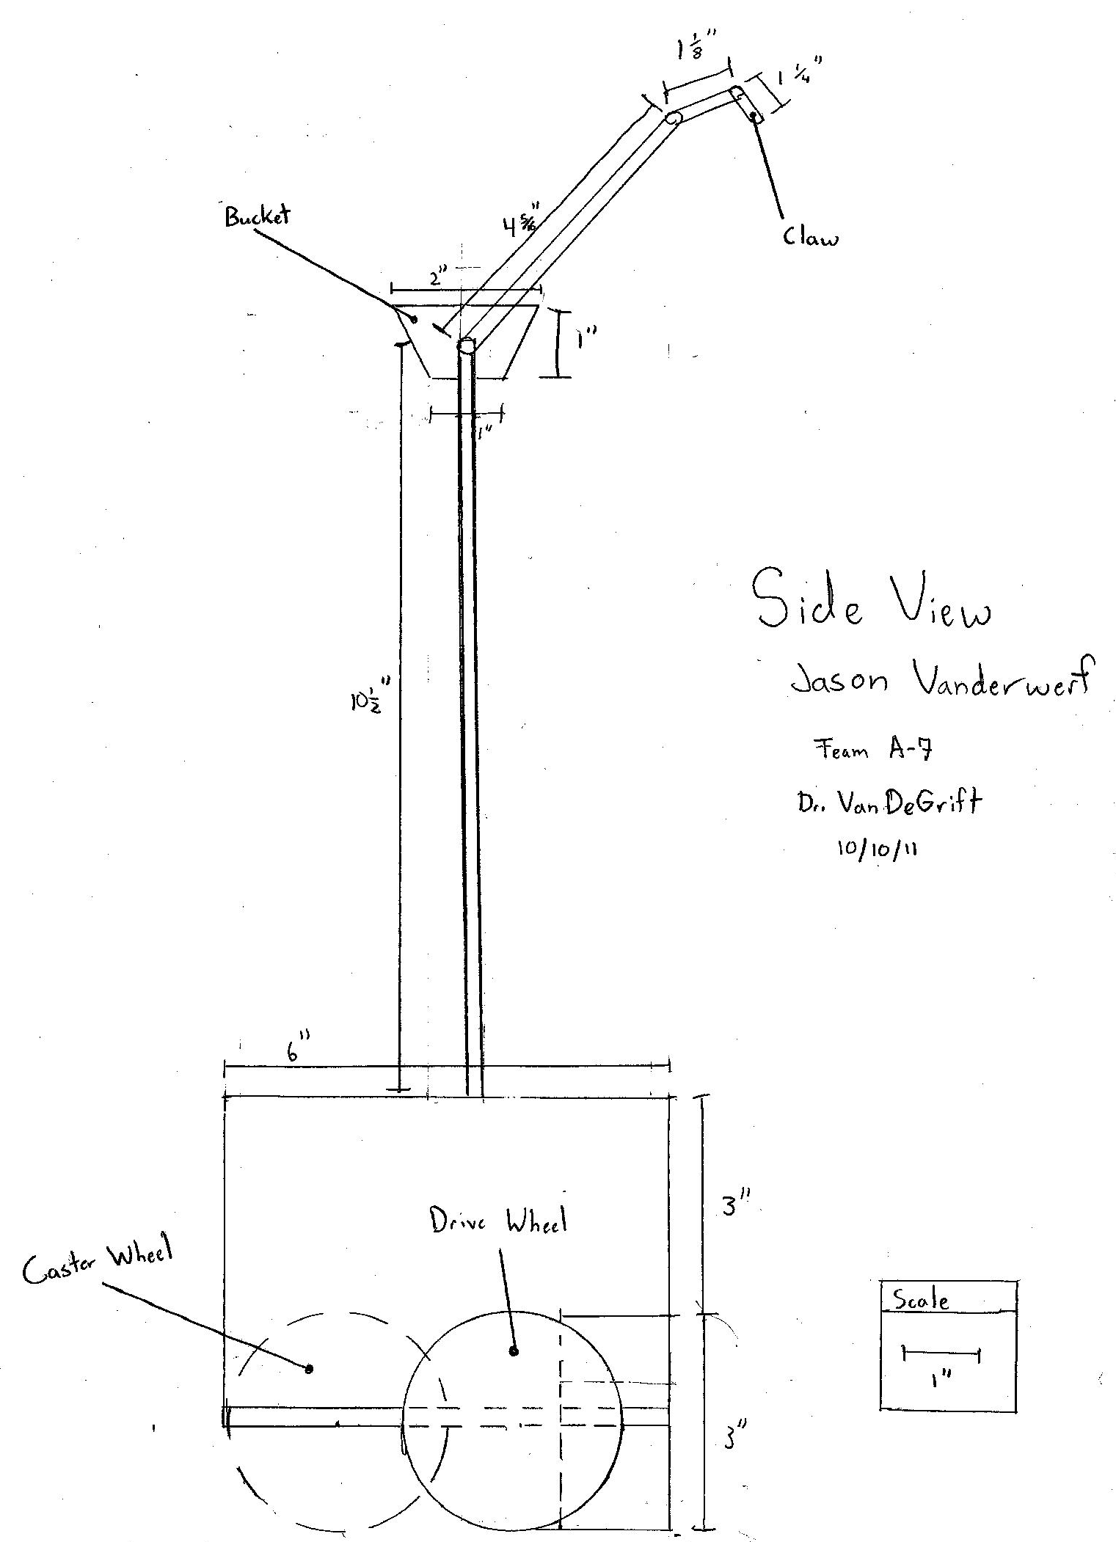
Figure 2 – Side View of Robot
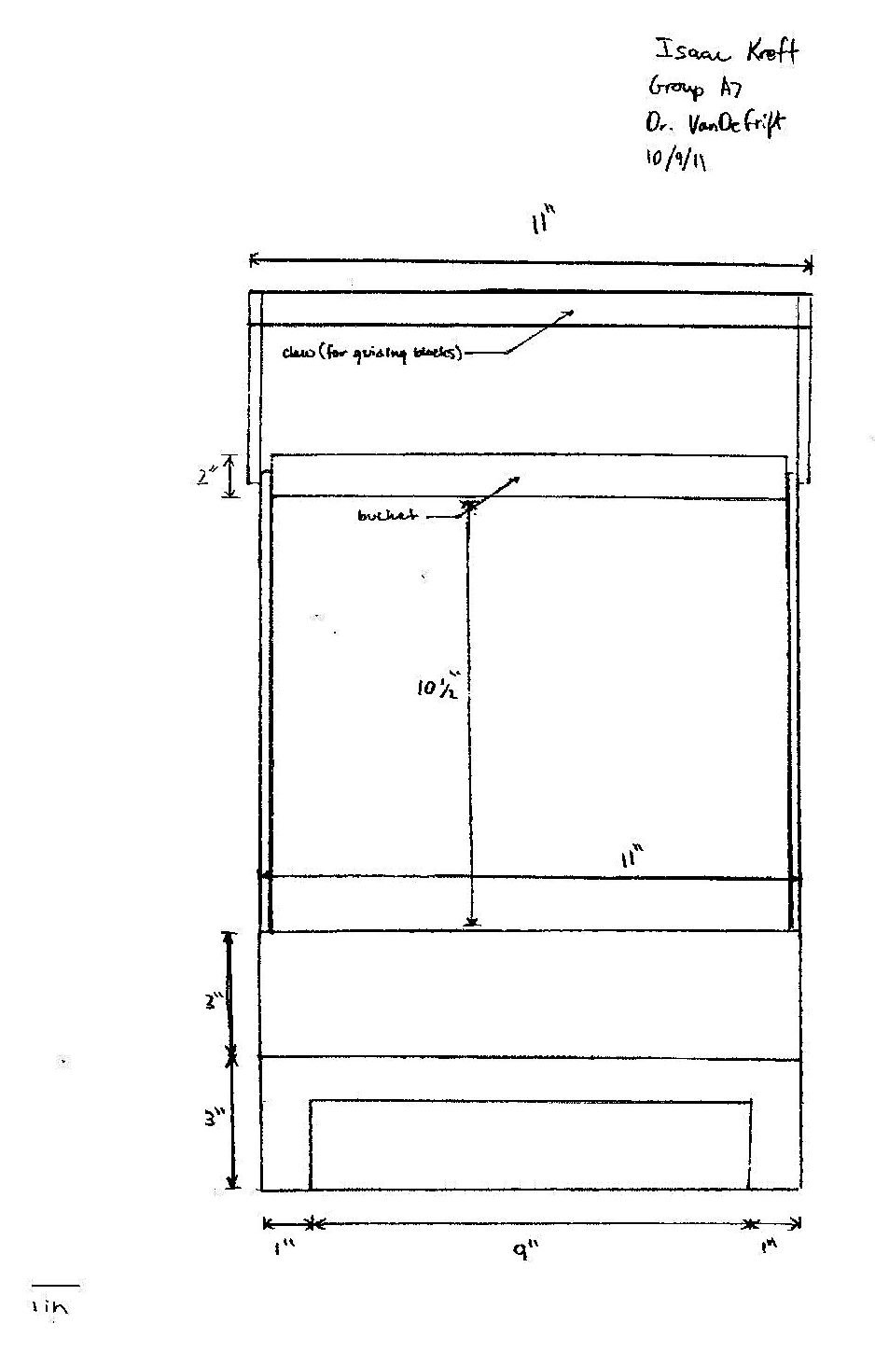
Figure 3 – Front View of Robot
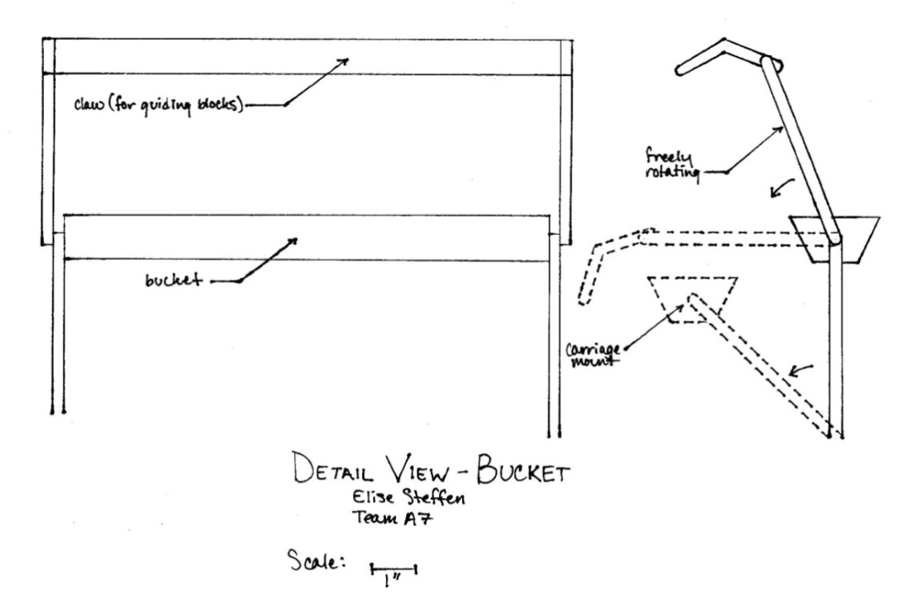
Figure 4 – Bucket Detail

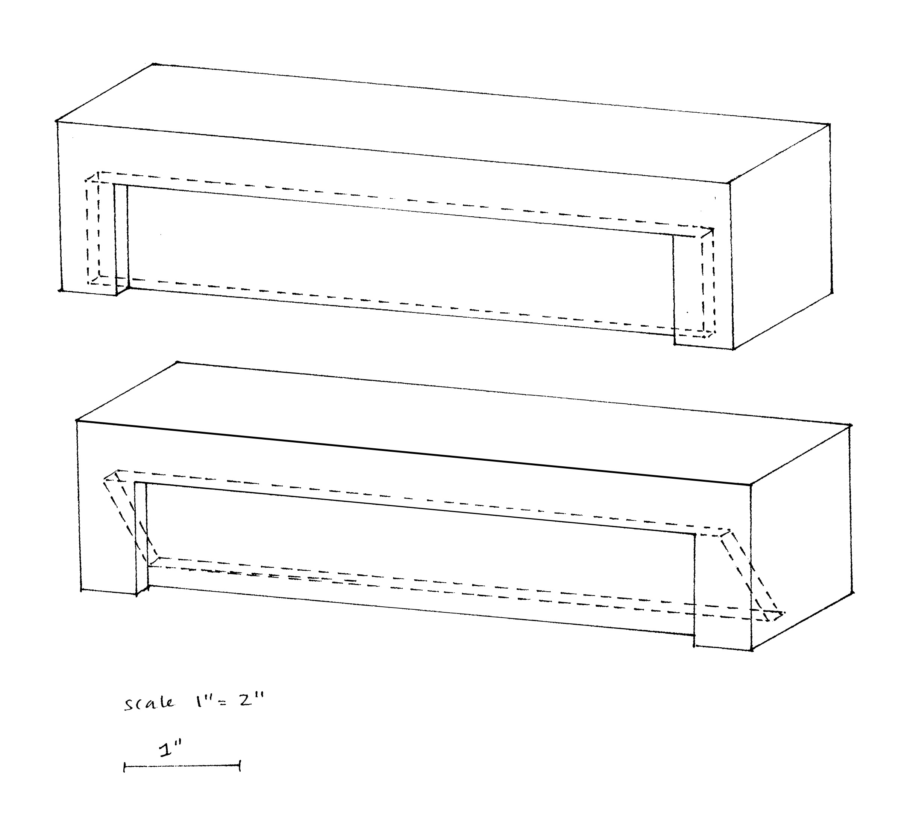
Figure 5 – Bulldozer Detail
4.0 Testing Plan
Team C7 plans to build the robot and its components in order to test each individually and then together. The bulldozer will be tested first as it has the most potential to work correctly. The bucket may need adjustments to its gathering device in order to work properly, so those will be fixed before moving on. Both the bulldozer and bucket devices will be used regardless of whether or not the robot can jump the ravine. If it turns out that the robot cannot jump the ravine, another alternative will be considered and the bulldozer and bucket incorporated into it.
5.0 Budget And Schedule
This section will describe the estimated cost of the robot and detail Team C7’s current schedule for completion and testing of the robot.
5.1 Materials and Costs
Team C7 will sacrifice low cost in order to win most points per time, and so will buy all of their materials. Team C7 plans to construct both the bucket and bulldozer out of cardboard, so cardboard sheet stock will be purchased. This means that the LEGO® adapters are also necessary. This design requires three motors – two for driving and one for powering the bucket – so the third motor must be purchased as well. Basawood strips will be needed for the gathering device and rubber bands are useful for many things and so Team C7 will air on the side of caution and purchase those as well. Specific costs and the total cost estimate are outlined in Table 2, below [1].
Table 2 – Materials and Costs
Item No. | Item Description | Unit Price | Quantity | Cost
110 | Flat LEGO® adaptor | $50 | 2 | $100
111 | Right-angle LEGO® adaptor | $50 | 2 | $100
201 | Cardboard sheet Stock | $25 | 1 | $25
208 | Rubber bands | $5 | 15 | $75
217 | Basawood strip | $50 | 2 | $100
501 | LEGO® motor | $200 | 1 | $200
- | LEGO® MINDSTORMS® kit | $100 | 1 | $100
- | - | - | - | Total: $600

5.2 Schedule
Team C7 plans to program parallel to construction; the program for the robot will evolve with the design. The bucket and bulldozer will be constructed first, followed by the body of the robot. Testing and resulting modifications will be done methodically, component by component, with the goal of having the final robot done by November 28th. The following table describes the schedule in more detail [2].

Table 3 – Schedule Team C7
Date | Task
10/12 | Begin programming and order materials
10/14 | Bucket finished
11/4 | Robot and all components (including programing) finished; begin testing
11/21 – 11/25 | Beta testing
11/28 | Final robot finished
12/3 | Competition Day

6.0 Summary
The competition requires teams to design, construct, and program a LEGO® MINDSTORMS® robot to collect blocks off a tiered platform, transport them across one of four obstacles of varying difficulty, and deposit them in a scoring zone. The obstacles vary in difficulty and therefore, a team’s score depends on the obstacle navigated by the robot. Scores also depend on which tier the blocks started on and where the blocks are deposited in the scoring area.
Team C7’s goal is to win points per time by collecting blocks off the top and bottom tiers simultaneously then jumping over the ravine at top speed before scoring. The design of Team C7’s robot includes a bucket (powered by a motor) with a gathering device (powered by gravity) to collect the top-tier blocks and a bulldozer-like device to collect the ground-level blocks. The three-wheel drive base allows for ease and precision in turning and the low placement of the NXT Brick and LEGO® motors counteract the weight of the bucket above the robot.
7.0 References
- UP School of Engineering, First Year Design Project, EGR 110-Introduction to Engineering, 9 October, 2011.
- UP School of Engineering, Introduction to Engineering – Fall Semester 2011 Syllabus, EGR 110-Introduction to Engineering, 9 October, 2011.

