The Electromagnetic (EM) Spectrum
Human eyes are designed to see only a narrow band of electromagnetic spectrum, from about 400nm to 700nm wave lengths (about 750THz to 430THz), but astronomical observations involve the entire range from long waves through gamma-rays. Some of spectra are observable on Earth, others are blocked by the Earth’s atmosphere and thus require satellites placed into space for observation. In this set of notes, we will discuss the four layers of Earth’s atmosphere and their effect on earth-based astronomy. We’ll then discuss sources of EM energy, starting with the sun.
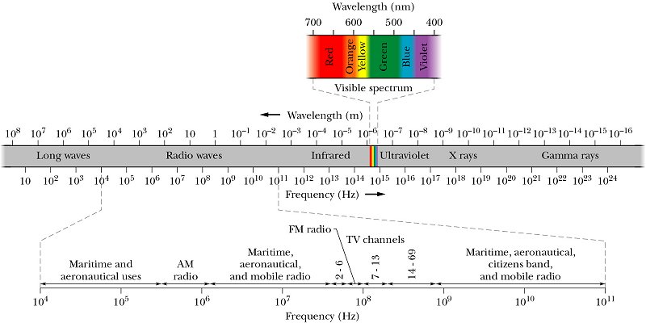
https://www.google.com/search?q=electromagnetic+spectrum&client=firefox-b-1-ab&source=lnms&tbm=isch&sa=X&ved=0ahUKEwiRxqvN57jdAhXLrVQKHWbGCF4Q_AUICigB&biw=1366&bih=603#imgdii=-5mbqJTtX_KqLM:&imgrc=MkKQHVhNJ_Dc4M:
Earth’s Atmosphere – some effects on astronomical observations.
We have already discussed one significant effect of Earth’s atmosphere: scintillation (the thing that causes stars to twinkle). Another effect is the filtering effect from Earth’s atmosphere, which prevents certain EM frequencies from reaching the ground.
{The following information on the Earth’s atmosphere is from: https://www.windows2universe.org/Earth/Atmosphere/Earth_atmosph_radiation_budget.html

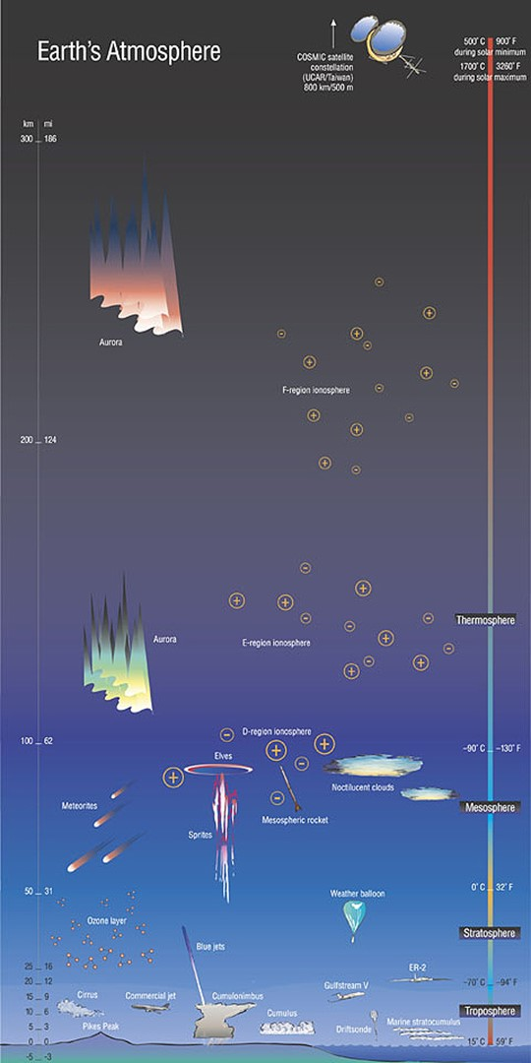
The layers of Earth’s atmosphere:
Troposphere: the troposphere is where we live. It is from the ground to about 7km-20km (23,000ft to 65,000ft, 4-11 miles). Air is warmest near the ground and cools at higher elevations. This creates convection currents which keep the air well mixed and creates weather. Most of the atmosphere’s clouds, moisture and dust are within the troposphere. An “inversion” is when the air is warmer at higher elevations – that inhibits convection and traps dirty air near the ground.
Stratosphere: above the troposphere up to about 50km (160,000ft, 31mi). Most of the atmospheric ozone (O₃) is in the stratosphere. Ozone absorbs ultraviolet energy from the sun. As a result, the stratosphere is warmer at higher elevations (unlike the troposphere). Therefore, there is little convective air currents in the stratosphere making the air “smooth” for flying aircraft.
Mesosphere: The top of the mesosphere is about 80km (260,000ft, 49mi) and the air is very thin. Most meteors burn up in the mesosphere.
The mesosphere and thermosphere contain sodium atoms which may be excited by 589 nm lasers – this is used with adaptive telescope optics. Perhaps we’ll discuss that later this semester.
Thermosphere: Above the mesosphere lies the extremely tenuous thermosphere. This layer is so thin, in fact, that many satellites orbit within it. This region is one in which temperatures once again rise with increasing altitude, reaching as high as 2,500°C (4,500°F) in the daytime! Embedded within the thermosphere are several layers of the ionosphere; regions where ionized gas particles can reflect radio waves, a feature that people used to send messages beyond the line-of-sight range of the horizon before the advent of satellites. The thermosphere extends from the mesosphere to somewhere up to between 500 and 1,000 km above the Earth's surface (300-600 miles). Many of the atoms and molecules in the thermosphere (and above) have lost electrons, thus becoming electrically charged ions; so the motions of particles in the upper atmosphere are partially influenced by electrical currents and Earth's magnetic field.
Exosphere: Though not universally recognized as a layer of our atmosphere, some scientists consider the exosphere to be the outermost layer of Earth's atmosphere. Starting at the top of the thermosphere, this extremely tenuous layer gradually gives way to the vacuum of interplanetary space.
“Outer Space”: there is no definitive altitude where “space” begins; however, the Karman Line (altitude of 100km, 328,000 ft, 62.1 miles) is generally accepted as defining outer-space. The International Space Station flies in low Earth orbit at 254 miles (400 km). Most low-orbit satellites orbit between 100-1200 miles (160-2000km).
Van Allen Belt: although not part of the atmosphere, it certainly is worthy of mention at this point. From Wikipedia:
A Van Allen radiation belt is a zone of energetic charged particles, most of which originate from the solar wind, that are captured by and held around a planet by that planet's magnetic field. Earth has two such belts and sometimes others may be temporarily created. The discovery of the belts is credited to James Van Allen, and as a result, Earth's belts are known as the Van Allen belts. Earth's two main belts extend from an altitude of about 500 to 58,000 km (310 to 36,040 mi) above the surface in which region radiation levels vary. Most of the particles that form the belts are thought to come from solar wind and other particles by cosmic rays. By trapping the solar wind, the magnetic field deflects those energetic particles and protects the atmosphere from destruction.
The belts are located in the inner region of Earth's magnetosphere. The belts trap energetic electrons and protons. Other nuclei, such as alpha particles, are less prevalent. The belts endanger satellites, which must have their sensitive components protected with adequate shielding if they spend significant time in that zone. In 2013, NASA reported that the Van Allen Probes had discovered a transient, third radiation belt, which was observed for four weeks until it was destroyed by a powerful, interplanetary shock wave from the Sun.
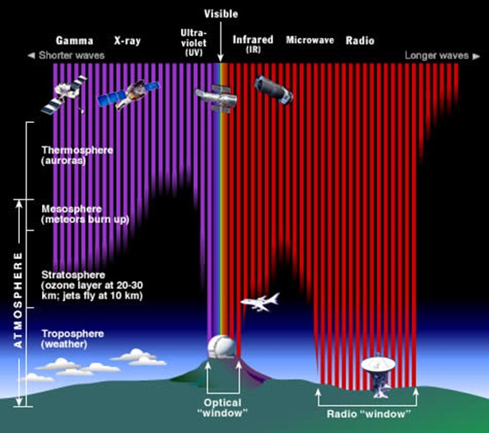
Filtering:
The Earth’s atmosphere filters some frequencies and transmits others. Clearly, it transmits visible wave lengths and most radio wave lengths as well. High energy EM waves (gamma rays, X-rays, some UV) are blocked before reaching Earth’s surface (whew – these waves can do serious harm to biology). Infrared, some microwave and radio waves are also filtered.

https://www.windows2universe.org/Earth/Atmosphere/Earth_atmosph_radiation_budget.html

Specific Atmospheric Effects
For astronomers, the atmosphere has two main effects: it affects “seeing” and “transparency”. Both seeing and transparency can change significantly during the night. Seeing refers to how steady the air is (poor seeing = atmospheric turbulence = stars are twinkling). Transparency of the atmosphere refers to how clear it is. Low transparency means much of the starlight is blocked by the atmosphere. Moisture and humidity lower the transparency, as does smoke, dust and other kinds of pollution. It’s not entirely unlike light pollution in that it washes out the fainter details of astronomical targets. In fact, poor transparency typically makes light pollution worse because it scatters the light around instead of letting it escape into space away from your cameras and optics. https://www.skyandtelescope.com/astronomy-blogs/imaging-foundations-richard-wright/seeing-vs-transparency-difference/
For amateur astronomers, the implications of atmospheric conditions are significant. Seeing conditions affect useable magnification and transparency affects how bright an object needs to be to observe it. If seeing is poor, stick to larger objects that don’t require high magnification. If transparency is poor, observe brighter objects, such as stars, star clusters, and planetary nebulae. Don’t forget to look up – there is less atmosphere straight up than there is near the horizon, so both seeing and transparency may be poor near the horizon, but good near the zenith. If both seeing and transparency are poor even straight overhead, get a cup of cocoa and go to bed early, or be patient, it may improve in the next 30 minutes...
Before you plan a major outing, it is wise to check the weather forecast – but “normal” forecasts don’t say much regarding seeing or transparency (except clouds = no transparency). The Clear Sky Chart website (http://www.cleardarksky.com/csk/) is worth checking out (see example below). It is a pretty good predictor of observing conditions for the next upcoming night or two, but extended forecasts are much less reliable.
Besides seeing and transparency, there are a few other atmospheric effects worth noting (and these too, are shown in the Clear Sky Chart). Wind usually makes seeing poor, but it also can make observing unpleasant. Wind can make your telescope move or vibrate, blow charts away, and is generally annoying at best. Humidity not only affects transparency, but if it reaches 100% relative humidity, dew forms. Dew on telescope optics will really mess up viewing. Shrouds or solid tubes on a reflector telescope usually is sufficient for keeping dew of the primary mirror, but dew shields (“extended tubes”) are often used on refractors and catadioptric telescopes. Electric warmers are also used to keep optics warm which prevents dew from forming. This can be a serious problem in humid climates.
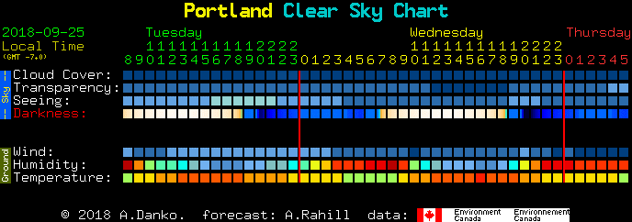

Let’s move beyond the atmosphere… Let there be light…
The Sun (most/all of the following information about the sun is from Wikipedia). The spectrum of the sun's solar radiation is close to that of a blackbody with a temperature of about 5,800 K. Components in the Earth’s atmosphere (including O₂, O₃, H₂O, CO₂) absorbs some of that energy, especially ultraviolet and X-ray. While the blackbody radiation is constant, there are transient events that produce different energies.
Sunspots are temporary phenomena on the Sun's photosphere that appear as spots darker than the surrounding areas (photosphere’s temperature is about 5800K). They are regions of reduced surface temperature (about 3800K) caused by concentrations of magnetic field flux that inhibit convection. Sunspots usually appear in pairs of opposite magnetic polarity. Their number varies according to the approximately 11-year solar cycle.
Individual sunspots or groups of sunspots may last anywhere from a few days to a few months, but eventually decay. Sunspots expand and contract as they move across the surface of the Sun, with diameters ranging from 16 km (10 mi) to 160,000 km (100,000 mi). The larger variety are visible from Earth without the aid of a telescope. They may travel at relative speeds, or proper motions, of a few hundred meters per second when they first emerge.
Indicating intense magnetic activity, sunspots accompany secondary phenomena such as coronal loops, prominences, and reconnection events. Most solar flares and coronal mass ejections originate in magnetically active regions around visible sunspot groupings. Similar phenomena indirectly observed on stars other than the Sun are commonly called starspots, and both light and dark spots have been measured.
(From Handbook of Practical Astronomy, G. D. Roth). Sunspots are a strong source radio waves. These are not part of blackbody radiation, but rather are the results of interaction between electrically charged particles and magnetic fields.
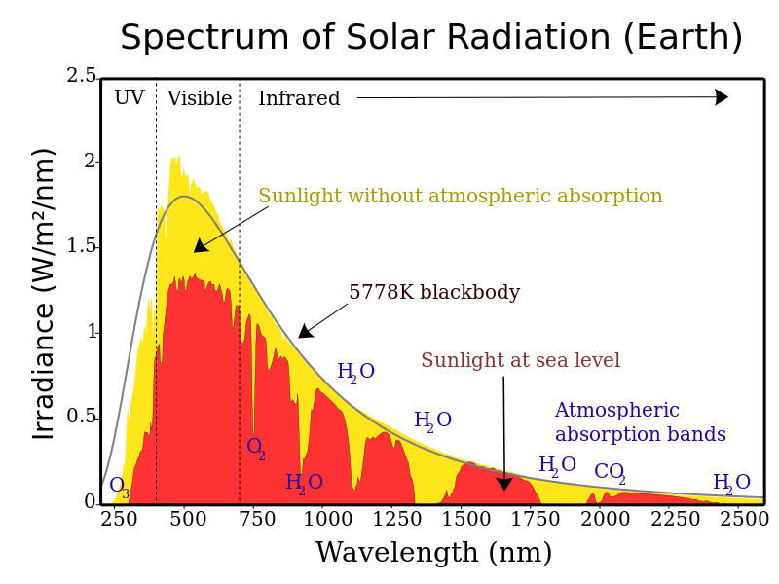
Solar irradiance spectrum above atmosphere and at surface. Extreme UV and X-rays are produced (at left of wavelength range shown) but comprise very small amounts of the Sun's total output power. (Wikipedia).
Coronal mass ejections release large quantities of matter and electromagnetic radiation into space above the Sun's surface, either near the corona (sometimes called a solar prominence), or farther into the planetary system, or beyond (interplanetary CME). The ejected material is a magnetized plasma consisting primarily of electrons and protons. While solar flares are very fast (being electromagnetic radiation), CMEs are relatively slow.
When the ejection is directed towards Earth and reaches it as an interplanetary CME (ICME), the shock wave of traveling mass causes a geomagnetic storm that may disrupt Earth's magnetosphere, compressing it on the day side and extending the night-side magnetic tail. When the magnetosphere reconnects on the nightside, it releases power on the order of terawatt scale, which is directed back toward Earth's upper atmosphere.
Solar energetic particles can cause particularly strong aurorae in large regions around Earth's magnetic poles. These are also known as the Northern Lights (aurora borealis) in the northern hemisphere, and the Southern Lights (aurora australis) in the southern hemisphere. Coronal mass ejections, along with solar flares of other origin, can disrupt radio transmissions and cause damage to satellites and electrical transmission line facilities, resulting in potentially massive and long-lasting power outages.
Energetic protons released by a CME can cause an increase in the number of free electrons in the ionosphere, especially in the high-latitude polar regions. The increase in free electrons can enhance radio wave absorption, especially within the D-region of the ionosphere, leading to Polar Cap Absorption (PCA) events.
Humans at high altitudes, as in airplanes or space stations, risk exposure to relatively intense solar particle events. The energy absorbed by astronauts is not reduced by a typical spacecraft shield design and, if any protection is provided, it would result from changes in the microscopic inhomogeneity of the energy absorption events.
Solar Flares (more from Wikipedia). A solar flare is a sudden flash of increased brightness on the Sun, usually observed near its surface. Powerful flares are often, but not always, accompanied by a coronal mass ejection. Even the most powerful flares are barely detectable in the total solar irradiance.
Solar flares occur in a power-law spectrum of magnitudes; an energy release of typically 1020 joules of energy is considered to be the median for a well-observed event, while a major event can emit up to 1025 joules.
Flares eject clouds of electrons, ions, and atoms through the Sun's corona into outer space, and also emit radio waves.
If ejection is in the direction of the Earth, the particles hitting the upper atmosphere can cause bright auroras, and may even disrupt long range radio communication. It usually takes a day or two for the particles to reach Earth. Flares also occur on other stars, where the term stellar flare applies.
Solar flares strongly influence the local space weather in the vicinity of the Earth. They can produce streams of highly energetic particles in the solar wind or stellar wind, known as a solar proton event. These particles can impact the Earth's magnetosphere (see main article at geomagnetic storm), and present radiation hazards to spacecraft and astronauts. Additionally, massive solar flares are sometimes accompanied by coronal mass ejections (CMEs) which can trigger geomagnetic storms that have been known to disable satellites and knock out terrestrial electric power grids for extended periods of time.
The soft X-ray flux of X class flares increases the ionization of the upper atmosphere, which can interfere with short-wave radio communication and can heat the outer atmosphere and thus increase the drag on low orbiting satellites, leading to orbital decay. Energetic particles in the magnetosphere contribute to the aurora borealis and aurora australis. Energy in the form of hard x-rays can be damaging to spacecraft electronics and are generally the result of large plasma ejection in the upper chromosphere.
The radiation risks posed by solar flares are a major concern in discussions of a manned mission to Mars, the Moon, or other planets. Energetic protons can pass through the human body, causing biochemical damage, presenting a hazard to astronauts during interplanetary travel. Some kind of physical or magnetic shielding would be required to protect the astronauts. Most proton storms take at least two hours from the time of visual detection to reach Earth's orbit. A solar flare on January 20, 2005 released the highest concentration of protons ever directly measured, giving astronauts as little as 15 minutes to reach shelter.

Sources of electromagnetic waves, other than the sun
Radio waves. The Earth’s atmosphere allows transmission of radio waves from about 20MHz to 300GHz (15m to 1mm wave lengths), so earth-based telescopes can be used to investigate the radio sky. As mentioned above, the interaction of charged particles within magnetic fields will produce radio waves. On the sun, sunspots are a principal source. Jupiter also produces radio waves in a similar way. The moon, being very cold, emits blackbody radiation at radio wave lengths.
Beyond the solar system, sources of radio waves are observed in the following (thanks Wikipedia):
The galactic center of the Milky Way was the first radio source to be detected. It contains a number of radio sources, including Sagittarius A* (pronounced “Sagittarius A-star”) and the supermassive black hole at its center.
Other sources include: supernova remnants, pulsars, complex molecules in star forming regions, Radio galaxies (many galaxies are strong radio emitters, called radio galaxies; more notable are Centaurus A and Messier 87).
Quasars (short for "quasi-stellar radio source") were one of the first point-like radio sources to be discovered. Quasars' extreme red shift led us to conclude that they are distant active galactic nuclei, believed to be powered by black holes. Active galactic nuclei have jets of charged particles which emit synchrotron radiation. One example is 3C 273, the optically brightest quasar in the sky.
The cosmic microwave background is blackbody background radiation left over from the Big Bang (the rapid expansion, roughly 13.8 billion years ago, that was the beginning of the universe).

At the other end of the spectrum from long waves and radio waves, literally, are gamma-rays. Radio waves are produced by low energy sources and quasars which are extremely “red shifted” due to their great distance. Gamma-rays are produced by very high energy sources such as blazars.
(Wikipedia) A blazar is an active galactic nucleus (AGN) with a relativistic jet (a jet composed of ionized matter traveling at nearly the speed of light) directed very nearly towards Earth. Relativistic beaming of electromagnetic radiation from the jet makes blazars appear much brighter than they would be if the jet were pointed in a direction away from the Earth. Blazars are powerful sources of emission across the electromagnetic spectrum and are observed to be sources of high-energy gamma ray photons. Blazars are highly variable sources, often undergoing rapid and dramatic fluctuations in brightness on short timescales (hours to days). Some blazar jets exhibit apparent superluminal motion, another consequence of material in the jet traveling toward the observer at nearly the speed of light.
Many objects produce a broad spectrum of light waves. For example, the following are images of the Crab Nebula recorded at different wave lengths. The Crab Nebula is also known as M1, the first object in Charles Messier’s list. The Crab Nebula is a supernova remnant (SNR) – the remains of a star that went supernova and appeared as a bright “new star” in 1054 AD. A fast spinning neutron star remains at its center (spinning at about 30 times per second). With each rotation, the star swings intense beams of radiation toward Earth, creating the pulsed emission characteristic of spinning neutron stars (also known as pulsars).

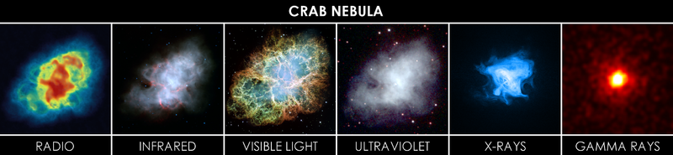
https://commons.wikimedia.org/wiki/File:Crab_Nebula_in_Multiple_Wavelengths.png
Radio: Very Large Array (earth-based telescope)
Infrared: Spitzer Space Telescope
Visible: Hubble Space Telescope
Ultraviolet: Swift Space Telescope
X-Rays: Chandra X-Ray Telescope
Gamma-Rays: Unlike the other images, which record light from the supernova remnant nebulosity, the gamma-rays were produced by the central neutron star. The gamma-rays are not produced with constant brightness. This image is of an outburst which was first detected by NASA's Fermi Gamma-ray Space Telescope on April 12, 2011. It lasted six days. Scientists think that the flares occur as the intense magnetic field near the pulsar undergoes sudden restructuring. Such changes can accelerate particles like electrons to velocities near the speed of light. As these high-speed electrons interact with the magnetic field, they emit gamma rays in a process known as synchrotron emission. To account for the observed emission, scientists say that the electrons must have energies 100 times greater than can be achieved in any particle accelerator on Earth. This makes them the highest-energy electrons known to be associated with any cosmic source.

